#1: Datasets
- Dataset on policing (standardized stop data) w/ categorical variables, 14 total variables: https://openpolicing.stanford.edu/data/
- Dataset on school fight songs w/ categorical and continuous variables, 23 total variables: https://github.com/fivethirtyeight/data/tree/master/fight-songs
- Dataset on Democratic and Republican ad campaigns w/ categorical and continuous variables, 32 total variables: https://github.com/fivethirtyeight/data/tree/master/primary-candidates-2018
- Philippines monthly price estimates w/ categorical and continuous variables, 109 total variables: https://microdata.worldbank.org/index.php/catalog/6172/data-dictionary/PHL_2021_RTFP_MKT?file_name=PHL_RTFP_mkt_2007_2024-06-04.csv
#2: Statistical Analysis Techniques
https://www.ncbi.nlm.nih.gov/pmc/articles/PMC6639881/
Probability and Statistical Inference by Robert Hogg
https://uca.edu/psychology/files/2013/08/Ch10-Experimental-Design_Statistical-Analysis-of-Data.pdf
Descriptive statistics (summarizing data using mean, median, standard deviation, etc.)
- Sample mean
- Sample median
- Sample mode
- Sample standard deviation
- Sample histogram
- Standard error
- Range
- Skew
Inferential statistics (draws conclusions from data using statistical tests)
- Hypothesis testing (one or two sample, independent or paired, equal or unequal variances)
  - What is the null hypothesis?
- Chi-squared test
- Pearson’s correlation
- Fischer’s exact test
- Student’s t test
- Median test for two populations
- Confidence intervals
- F test (ANOVA)
- Linear regression
----- NOTES -----
Discrete data – use nonparametric methods
Continuous data – use parametric (assumes that variable is continuous and normally distributed) or nonparametric methods
Different techniques required for large/small samples, normal/non-normal distributions, categorical/continuous outcomes, paired/unpaired nature of observations
Parametric tests:
- Student’s t-test (one sample t-test, independent samples t-test, paired samples t-test) used to compare means between two groups
- F test (one-way ANOVA, repeated measures ANOVA, etc.) used to compare means among three or more groups
- Pearson correlation coefficient
- Linear regression
Non-parametric versions of the above tests:
- Mann-Whitney U test
- Wilcoxon test
- Kruskal-Wallis H test
- Median test
- Friedman test
- Spearman rank correlation coefficient
- Log linear regression
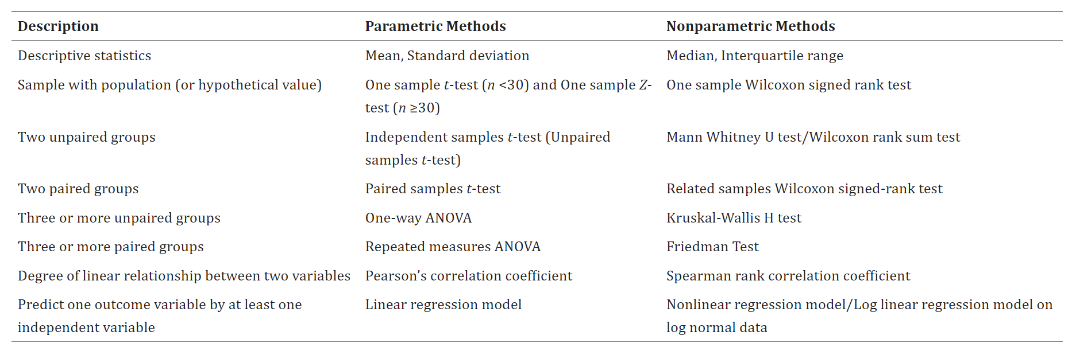
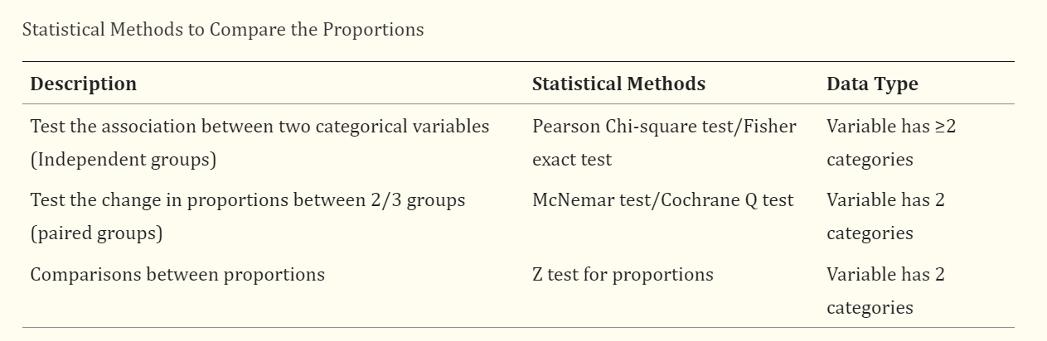
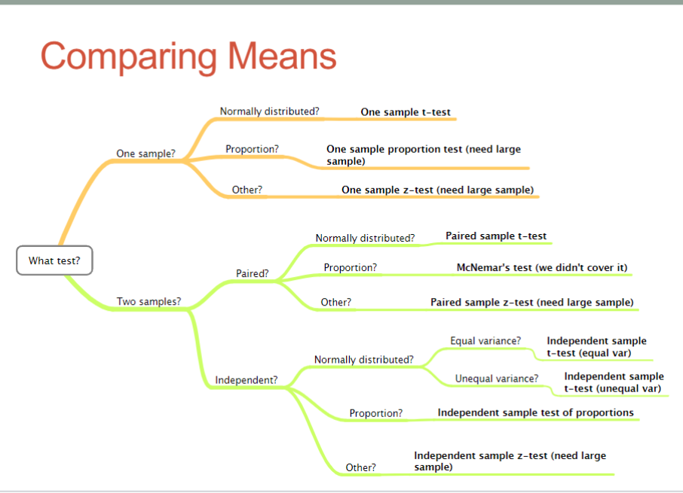
6-7:
Datasets:
Tableau Superstore Sample Data

Statistical Questions/Techniques:
https://www.itl.nist.gov/div898/handbook/index.htm
- What is a typical value?
- What is the uncertainty for a typical value?
- What is a good distributional fit for a set of numbers?
- What is a percentile?
- Does an engineering modification have an effect?
- Does a factor have an effect?
- What are the most important factors?
- Are measurements coming from different laboratories equivalent?
- What is the best function for relating a response variable to a set of factor variables?
- What are the best settings for factors?
- Can we separate signal from noise in time dependent data?
- Can we extract any structure from multivariate data?
- Does the data have outliers?
- Mean, median, mode
- Confidence limits
- Two-sample t test for equal means
- One sample t-test
- One factor analysis of variance
- Multifactor analysis of variance
- Variance, standard deviation, range, average absolute deviation, median absolute deviation, interquartile range
- Bartlett’s test
- Chi-Squared test
- F test
- Levene Test
- Skew/kurtosis
- Autocorrelation (detecting non-randomness)
- Runs Test (detecting non-randomness)
- Anderson-Darling Test (test if a sample came from a specific distribution)
- Chi-Square Goodness of Fit Test
- Kolmogorov-Smirnov Test (test if a sample came from a specific distribution)
- Grubbs Test
- Tietjen-Moore Test
- Generalized Extreme Deviate Test
- Yates Algorithm (estimate factor effects in 2-level factorial designs)
- Time series analysis
6-10:
- Correlation scatterplot
- Correlation heatmap
- Logistic regression – is this a form of statistical analysis?
  - And coefficients
- Bar plot
- Mean, median, mode
- Data preprocessing
- Chi-squared test
- Principal component analysis
- Time series decomposition
- SARIMA
- Forecast and plot results of ML model against test data
- Test train split
- T-tests
- ANOVA
- Regression analysis
- Outliers
- Data cleaning
- Distribution of data across variables
- Pairwise comparisons
- Reporting
- Proportions
- Describe data structure and contents, summarize key variables
- Removing duplicates
- Identifying and removing missing values
- Identify and correct any errors in the dataset – verify encoding, investigate outliers, ensure correct values
- Standardize values
- Create composite variables

https://mimic.mit.edu/
https://github.com/smerdov/eSports_Sensors_Dataset
https://data.mendeley.com/datasets/23553sm4tn/3
https://paperswithcode.com/datasets?mod=tabular

Goals:
- Choose dataset
- Come up with questions
- Anomaly detection
- Time series analysis

